FOR IMMEDIATE RELEASE:
Cascade Books
Suzanne Logan
(541) 344-1528 x122
suzie@wipfandstock.com

Sight for the Blind: Making Visible at Table the Wounds of Racism and White Privilege
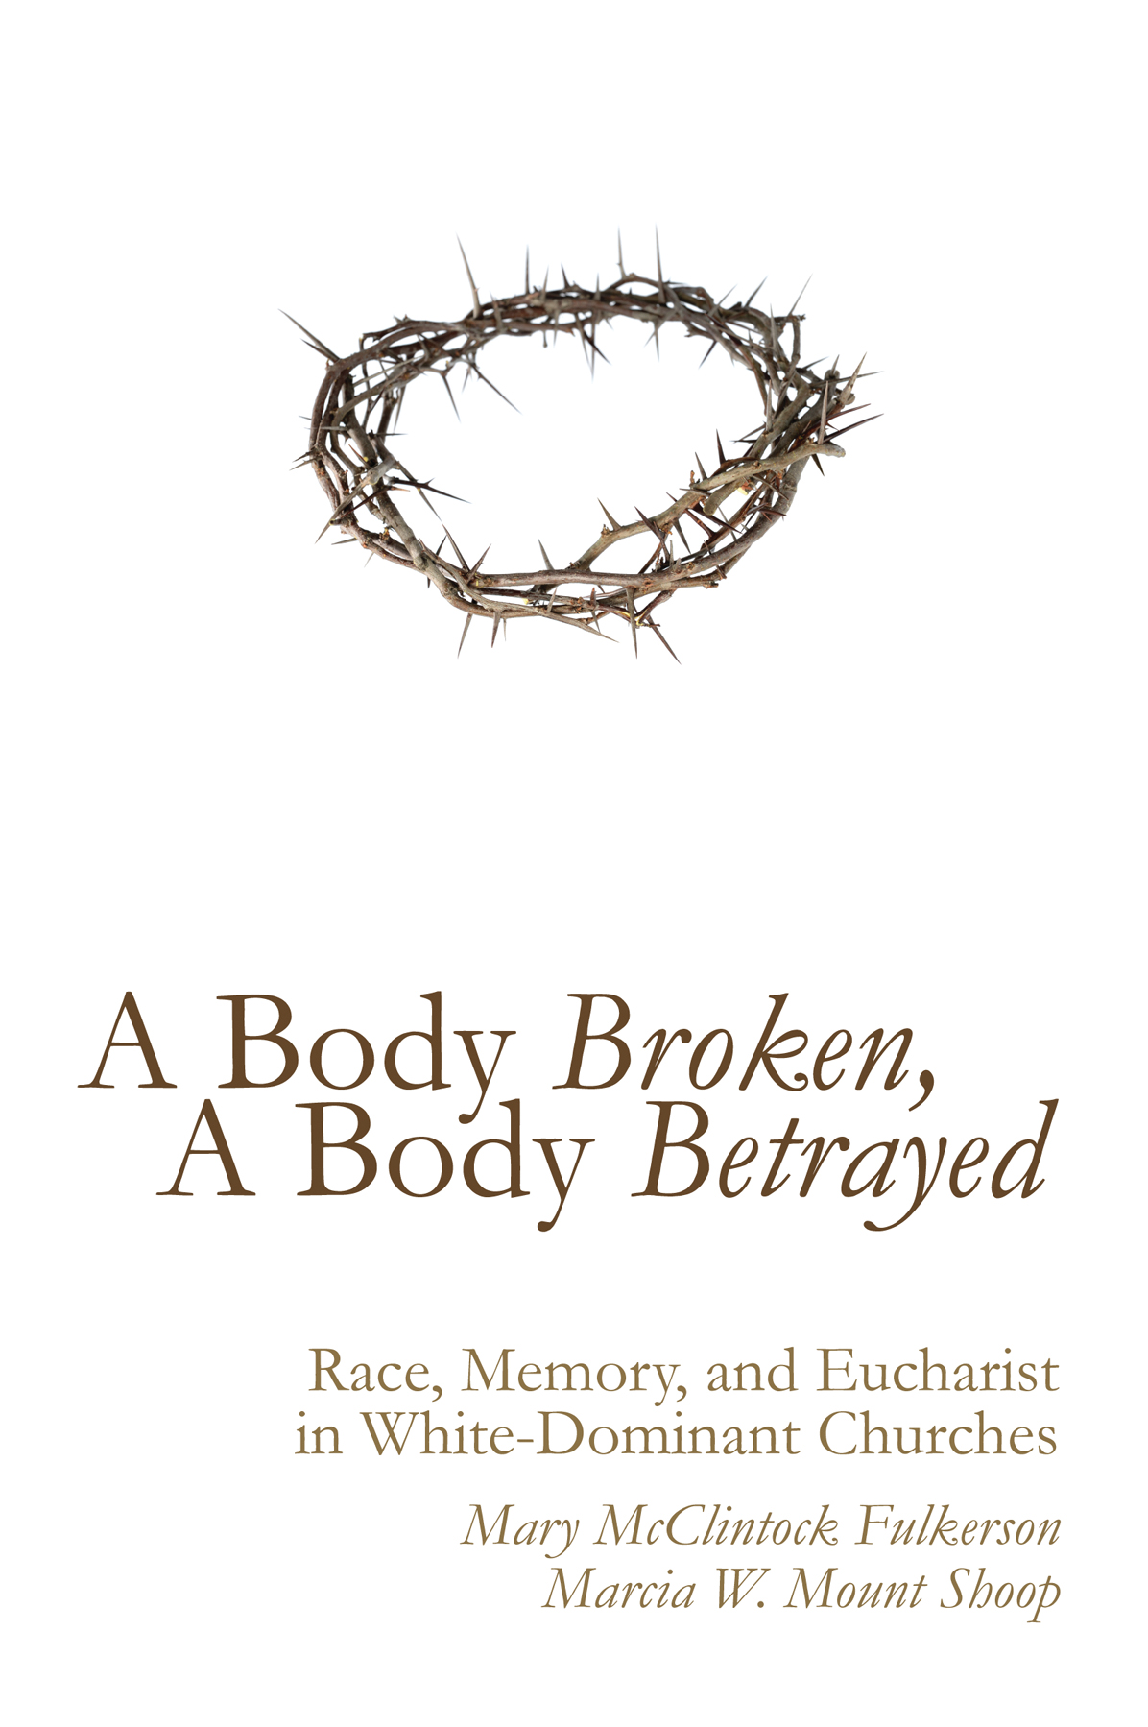
Race and privilege are issues that cry out for new kinds of attention and healing in American society. More specifically, we are being called to surface the dynamics of whiteness especially in contexts where whites have had the most power in America. The church is one of those contexts—particularly churches that have traditionally been seen as the stalwarts of the American religious landscape: mainline Protestant churches.

In A Body Broken, A Body Betrayed theologians and Presbyterian ministers Mary McClintock Fulkerson and Marcia Mount Shoop invite us to acknowledge and address the wounds of race and privilege that continue to harm and diminish the life of the church. Using Eucharist as a template for both the church’s blindness and for Christ’s redemptive capacity, this book invites faith communities, especially white-dominant churches, into new ways of re-membering what it means to be the Body of Christ.

Mary McClintock Fulkerson is Professor of Theology at Duke Divinity School in Durham, North Carolina, and an ordained minister in the Presbyterian Church (U.S.A.). She is the author of Changing the Subject: Women’s Discourses and Feminist Theology (1994) and Places of Redemption: Theology for a Worldly Church (2007).

Marcia W. Mount Shoop is a theologian, minister, and author of Let the Bones Dance: Embodiment and the Body of Christ (2010) and Touchdowns for Jesus and Other Signs of Apocalypse: Lifting the Veil on Big-Time Sports (2014). She blogs at www.marciamountshoop.com.

A Body Broken, A Body Betrayed : Race, Memory, and Eucharist in White-Dominant Churches/ 9781620329047 / paper / available / list price $14.00

“The problem this volume addresses—the quiet, subtle way race deforms predominantly white, Presbyterian congregations—couldn’t be more timely. Its authors bring to this fraught subject a well-honed commitment to racial justice and a wealth of experience in Presbyterian congregational life. . . . Clergy, scholars, and laity have much to gain from this insightful and accessible blend of trenchant academic analysis, theological wisdom, and genuine compassion.”
Praise for A Body Broken, A Body Betrayed
—Ellen T. Armour, Carpenter Associate Professor of Feminist Theology, Vanderbilt Divinity School

“[This book] guides us through the painful process of acknowledging the existence of racism in the church. It calls us to the difficult spiritual practice of self-reflection, self-examination, and truth-telling. . . . This book is an invitation to approach the Lord's Table in authenticity to receive the nourishment that can foster reconciliation on a personal and communal level.”
—Wanda M. Lundy, Director of Doctor of Ministry program, New York Theological Seminary

“A bold invitation to explore the healing opportunities that Jesus offers us through a life together at the table, where denial, fear, betrayal, and abuse can be explored and cured, creating the possibility that we might move beyond the dismemberment of the body of Christ.”
—Magdalena I. García, teaching elder in the Presbytery of Chicago, hospice chaplain

“A prayer request is being answered with this book by two of this country’s premier feminist theologians. . . . Before we can understand the Eucharist as an answer to the racial condition we first must grasp how it questions white privilege, and Fulkerson and Shoop help us do this.”
—Willie James Jennings, Yale Divinity School

Question and Answer with the authors

What is the book about?

This book is about racism and the church, but it goes about exploring those dynamics in some unexpected and unconventional ways. For instance, we explore, among other layers of white culture, the prominent phrase, “colorblindness.” This is a phrase and a mentality that has been employed by many white communities, including churches, to claim our lack of prejudice. Ostensibly used to suggest that “we don’t see color, just people” in a welcoming way, it in fact indicates a prejudice that ignores, and/or is oblivious to, the deeply entrenched effects of historical and systemic racism and its ongoing reality.

Why did you write this book?

We have both written previously about race and the church in different modes. Marcia’s first book was about embodiment, with treatment of the way race afflicts the church. And her second book explored (among other things) the subtleties of race and white culture in big-time sports. Mary’s previous book was based upon an ethnographic study of an interracial church. For both of us those projects helped surface some of our own deeply embedded “blindness” about racism and its effects. We both wanted to keep exploring the dynamics of white culture. We have both also had very personal experiences of how ignoring these dynamics trivializes who the church can be in the world.

How did you choose Eucharist as the template for a discussion about race and white culture?

Eucharist embodies telling iconography about both the church’s aspirations and the church’s realities. It boasts themes of radical welcome and community, as modeled in the life of Jesus. But it has not been functioning to bring people together across lines of difference in mainline churches. We felt this embodied, sacramental icon of Christian liturgy and identity could serve as a potent window into some of the dynamics and some of the possibilities of Christian life in white-dominant communities.

What do you hope to accomplish with this book?

We hope to provide language and a framework for conversations about race in white-dominant churches to deepen and to be transformative. Since many people assume that overt and legalized racism have been “cured,” this less acknowledged but deeply problematic layer of racism needs our attention for the church to truly be a healing witness to the world.

Who would be interested in this book?

Christians of all shapes and sizes can connect to this book. We hope that theologians, ministers, ethicists, justice-seekers, Sunday school classes, book studies, seminarians, graduate students, anti-racism activists, and any who follow Jesus’ lead into the most fraught spaces in American culture find something that enriches their work and their perspectives in this book.

Why has racism had such a tenacious hold on the church?

Read the book for a more thorough answer, but the short answer is it is hard to heal wounds that are concealed in some of the ways that racism is in the church. Seeing things anew is an important opportunity for people of good faith to finally address some of the dynamics of race that have diminished our lives together as church the most.

An Excerpt from A Body Broken, A Body Betrayed
Far from being able to name and dress our collective wounds around racism, many of the ways in which racism most afflicts the church remain concealed from our consciousness, and sometimes even camouflaged as virtue. “When I look at a person, I don’t see color—I see a child of God” rolls off the tongues of many Christians. These words are understood and embraced as articulating the unbounded grace and generosity of God’s love. And through this aspiration of loving all people, regardless of their demographic profile, many people have felt called to practice an ethic of colorblindness.

This colorblind aspiration creates a necessary amnesia or unknowing around racialized systems, histories, and bodies. And this aspiration easily finds a home in communities deeply and often unconsciously shaped by whiteness and white culture. These white-derived aspirations and habits are seamlessly coupled with many of the common assumptions of privilege—that systems are fair, that individuals are the center of how we understand rights and responsibilities, and that being educated in and conforming to societal norms is possible for everyone when they are given the “right tools.” In the church these values manifest as mission statements and faith practices. And the resulting collective habituations and dispositions encouraged and practiced by churches focus on things like radical hospitality, service, and outreach to “the least of these.”

Often, the rhetoric heard in mainline Protestant worship— from prayer, to sermon, to offering—reifies the assumption that everyone in church is called to help those in need. These people in need are described (sometimes subtly, other times not so subtly) as being outside the faith communities who seek to help them. “We” the church are helping “them” the poor, the disenfranchised, the oppressed, and the disadvantaged. These impulses toward service, charity, and outreach are taught as universal Christian virtues. The habituations and assumptions that they entail are not collectively explored in terms of race or social location. The stealthy affliction of colorblindness permeates faith communities with a fluid infiltration—it infects institutions of white culture, like the church, camouflaged as the very virtues to which we aspire as communities. And these virtues are not understood as culturally derived; they are to be exercised without regard to color and culture.

With reverberations of Paul Tillich’s category of the demonic, the habits and practices of colorblindness distort and contort provisional goods by totalizing them, by being blind to their own finite and limited origins. Tillich uses the fictional character of Faust to illustrate the demonic. Faust desires all knowledge and so makes a deal with the devil to know everything. Knowledge itself is not demonic; the desire to attain all knowledge, to collapse all of reality into oneself, is demonic. Colorblindness is blind to its own color, to its bias toward the absence of color. Colorblindness distorts a culturally derived value by making it an infinite value—a God-derived value. The language of colorblindness in the church takes the aspirations of whiteness to erase distinctions, to ignore histories of oppression, and to bypass dissonant narratives and overlays them onto what God wants for us as people of faith.
God’s kingdom, we hear again and again, is a place of unity. Christ’s Body, we hear again and again, is a place where we are all one body. These aspirations of oneness and reconciliation are not necessarily demonic; blindness to the originary desire to make them in the image of white culture, however, obscures a demonic reality. These aspirations are instilled with a dangerous obliviousness to the power of whiteness and its habit of obscuring its own woundedness and its own capacity to wound. Surfacing the marks of colorblindness in eucharistic practice means inviting visibility where there has been invisibility. This invisibility has the capacity to conceal our collective wounds around race in plain sight. And our very stories, aspirations, and habituations geared toward overcoming racism are some of the dynamics that have increased its hold and its harm among us.

